Childhood Anemia in Nigeria
Socioeconomic Factors and Anemia Severity among Children Aged 0–59 Months
Aishatu Abubakar
Data source: 2018 Nigeria Demographic and Health Survey (NDHS)
Tool: Google Sheets (pivot tables)
Analysis: Descriptive cross-tabulation and visualization

INTRODUCTION AND BACKGROUND
Anemia in early childhood can affect children’s health and development. Understanding how anemia severity varies across socioeconomic and residential groups can help identify populations that may require greater attention from health programs, NGOs and government agencies.
This project uses cross-sectional data from the 2018 Nigeria Demographic and Health Survey (NDHS), a nationally representative household survey conducted roughly every five years that covers all 36 Nigerian states plus the Federal Capital Territory (FCT). The target population is children aged 0–59 months and their mothers, aged 15–49 years.
Rather than answering a question set by someone else, this project set out to find a focused question that the data can answer and that a public-health audience would care about: how does the severity of childhood anemia differ across household wealth, mother’s education and place of residence?

RESEARCH QUESTION
Which socioeconomic factors, household wealth and mother’s education, show the strongest differences in childhood anemia severity, and do these patterns differ between urban and rural areas?
Why it matters. Wealth and education are factors that programs can use to target support, and urban–rural residence is a practical way to plan service delivery. A clear picture of where moderate and severe anemia is most concentrated helps show which children may need greater attention.
Why the data can answer it. The dataset records each child’s anemia level (Not anaemic, Mild, Moderate, Severe) alongside the household wealth index, the mother’s highest education level and the type of place of residence, so severity can be compared directly across these groups.

OBJECTIVES
- To describe the overall distribution of anemia severity among children aged 0–59 months with recorded anemia measurements.
- To compare the share of children with moderate or severe anemia across household wealth groups.
- To compare the share of children with moderate or severe anemia across mother’s education levels.
- To compare the share of children with moderate or severe anemia between urban and rural areas.
- To identify which factor shows the largest descriptive differences, and to state the findings in plain language without claiming statistical significance or causation.

DATA SOURCE AND STUDY POPULATION
The data come from the 2018 Nigeria Demographic and Health Survey (NDHS). The dataset supplied for this project contains 33,924 records of children aged 0–59 months and their mothers (17 columns).
Analysis population. The anemia severity comparisons include the 10,182 children who had a recorded child anemia measurement. The remaining 23,742 records had no recorded child anemia measurement and are not part of the severity comparisons.

VARIABLES
The variables used in the analysis are summarized below. Other columns in the dataset (for example mother’s age group, births in the last five years, age at first birth, bed net use, fever, iron supplementation and breastfeeding initiation) were reviewed during exploration but were not used, in order to keep the question, narrow and well answered.
Handling the two anemia columns. The dataset contains two near-duplicate anemia and hemoglobin pairs: one adjusted for altitude and smoking, and one adjusted for altitude only. Because the smoking adjustment relates to the mother, the altitude-only pair was used as the child measure. This column has 10,182 recorded values, which is the analysis population used throughout this report.

Table 1. Variables used in the analysis
Variable | Role | Description / categories
Child anemia level | Outcome | Severity of anemia in the child: Not anemic, Mild, Moderate, Severe. Also reported as combined “moderate/severe”.
Wealth index combined | Factor | Household wealth: Poorest, Poorer, Middle, Richer, Richest.
Highest educational level | Factor | Mother’s education: No education, Primary, Secondary, Higher.
Type of place of residence | Factor | Urban or Rural (based on the sample cluster).
Child hemoglobin level (adjusted for altitude) | Supporting | Original hemoglobin values retained and checked for unusual values.

DATA CLEANING
- Standardized education categories so that mother’s education is reported in four consistent groups: No education, Primary, Secondary and Higher.
- Preserved missing anemia measurements rather than filling them in or treating them as “Not anemic.” No anemia values were estimated or imputed.
- Retained original hemoglobin values without altering or removing them.
- Checked unusual hemoglobin values and kept the original values as recorded.
- Used Google Sheets pivot tables to build the cross-tabulations.

Missing anemia measurements
Of the 33,924 records, 10,182 (30.0%) had a recorded child anemia measurement and 23,742 (70.0%) did not. Missing values were deliberately preserved as missing. A missing measurement is not the same as “not anemic,” so treating these records as healthy would have understated anemia, and guessing the missing values would have added information that the survey did not collect. The dataset does not state why measurements are missing, so this report does not assume a reason. Instead, the severity comparisons are restricted to children with recorded measurements, and all percentages in this report are calculated out of the 10,182 children in that group (or the relevant sub-group within it).

ANALYSIS METHOD
Tool. Google Sheets was used for the analysis and charts. It suits a focused comparison of categories and makes the counts easy to check and reproduce.
Technique. Descriptive cross-tabulation using pivot tables. For each factor (household wealth, mother’s education, residence), children were grouped by category and the percentage in each severity level was calculated within each group (row percentages). Moderate and Severe were also combined into a single “moderate/severe” measure to summarize the more serious forms of anemia. Results are shown as tables and 100% stacked bar charts.
What was not done. No statistical significance testing, regression or causal modelling was performed. A simple cross-tabulation was chosen because it matches a question about differences between groups. All findings are descriptive.

RESULTS

Overall severity of childhood anemia
Among the 10,182 children with recorded anemia measurements, moderate anemia was the largest single severity category, followed by not anemic and mild. Severe anemia was the smallest category.
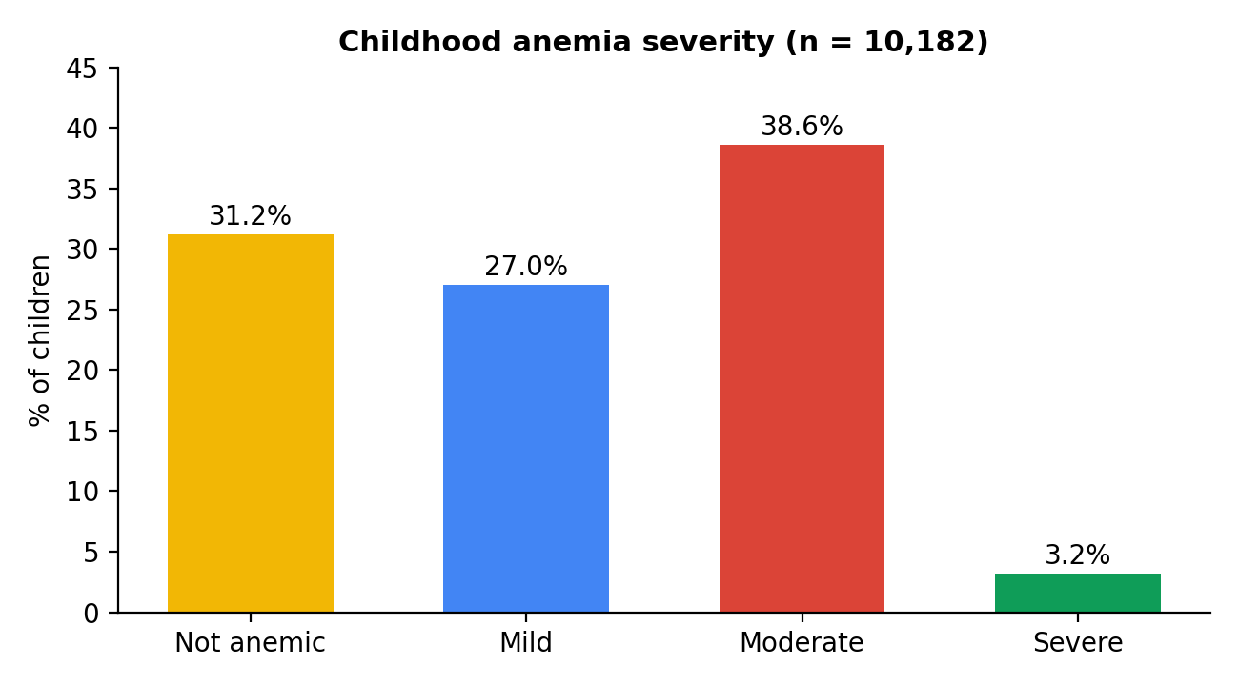
Figure 1. Overall childhood anemia severity among children with recorded measurements.

Table 2. Overall childhood anemia severity (n = 10,182)
Severity | Children | Percentage
Not anemic | 3,179 | 31.2%
Mild | 2,754 | 27.0%
Moderate | 3,927 | 38.6%
Severe | 322 | 3.2%
Total | 10,182 | 100.0%

In plain terms, 38.6% of these children had moderate anemia and a further 3.2% had severe anemia, while 31.2% were not anemic.

Household wealth
Moderate/severe anemia was 24.0% among children in the richest households compared with 54.0% among children in the poorest households. The share who were not anemic showed the opposite pattern: 46.5% in the richest households versus 20.5% in the poorest. Moderate/severe anemia was lower in each step from the poorest to the richest group.
Table 3. Anemia severity by household wealth
Group | n | Not anemic | Mild | Moderate | Severe | Moderate + Severe
Poorest | 2,042 | 20.5% | 25.6% | 48.1% | 5.8% | 54.0%
Poorer | 2,036 | 24.5% | 25.8% | 45.5% | 4.3% | 49.8%
Middle | 2,249 | 32.4% | 26.5% | 38.5% | 2.6% | 41.1%
Richer | 2,141 | 34.4% | 28.3% | 35.0% | 2.2% | 37.3%
Richest | 1,714 | 46.5% | 29.5% | 23.5% | 0.5% | 24.0%
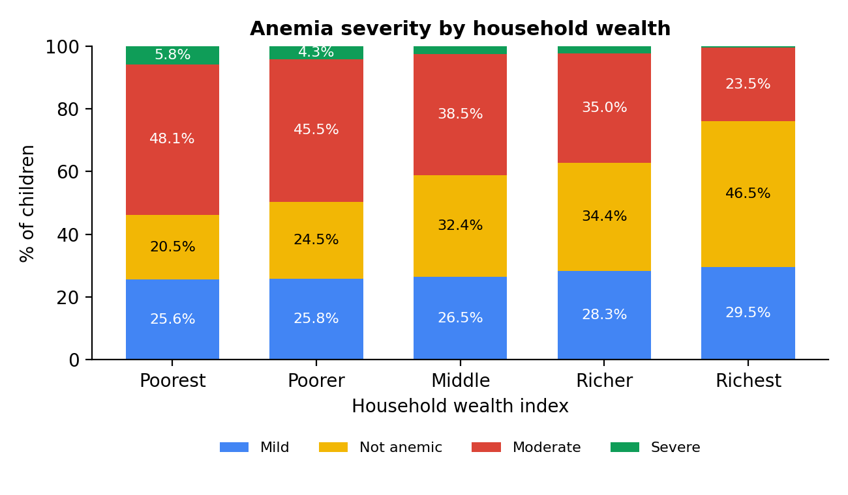
Figure 2. Anemia severity by household wealth (row percentages).

Mother’s education
Moderate/severe anemia was 20.2% among children whose mothers had higher education, compared with 50.3% among those whose mothers had no education. Moderate/severe anemia was lower at each higher level of education: No education 50.3%, Primary 43.6%, Secondary 37.0% and Higher 20.2%.
Table 4. Anemia severity by mother’s education
Group | n | Not anemic | Mild | Moderate | Severe | Moderate + Severe
No education | 3,896 | 24.2% | 25.5% | 45.6% | 4.7% | 50.3%
Primary | 1,733 | 29.0% | 27.5% | 40.5% | 3.1% | 43.6%
Secondary | 3,644 | 34.9% | 28.1% | 34.8% | 2.3% | 37.0%
Higher | 909 | 51.0% | 28.7% | 20.0% | 0.2% | 20.2%
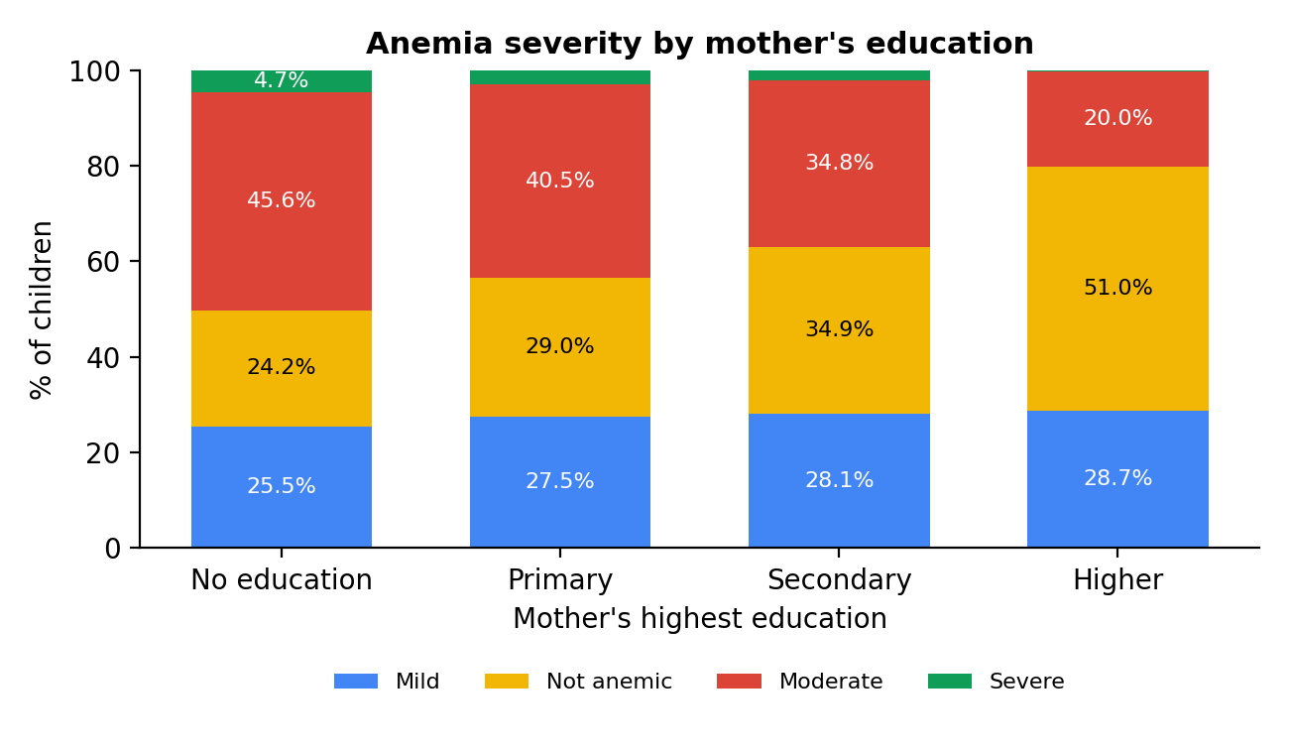
Figure 3. Anemia severity by mother’s education (row percentages).

PLACE OF RESIDENCE
Moderate/severe anemia was 34.7% in urban areas compared with 46.2% in rural areas.
Table 5. Anemia severity by place of residence
Group | n | Not anemic | Mild | Moderate | Severe | Moderate + Severe
Rural | 6,219 | 27.1% | 26.7% | 41.9% | 4.3% | 46.2%
Urban | 3,963 | 37.7% | 27.6% | 33.3% | 1.4% | 34.7%
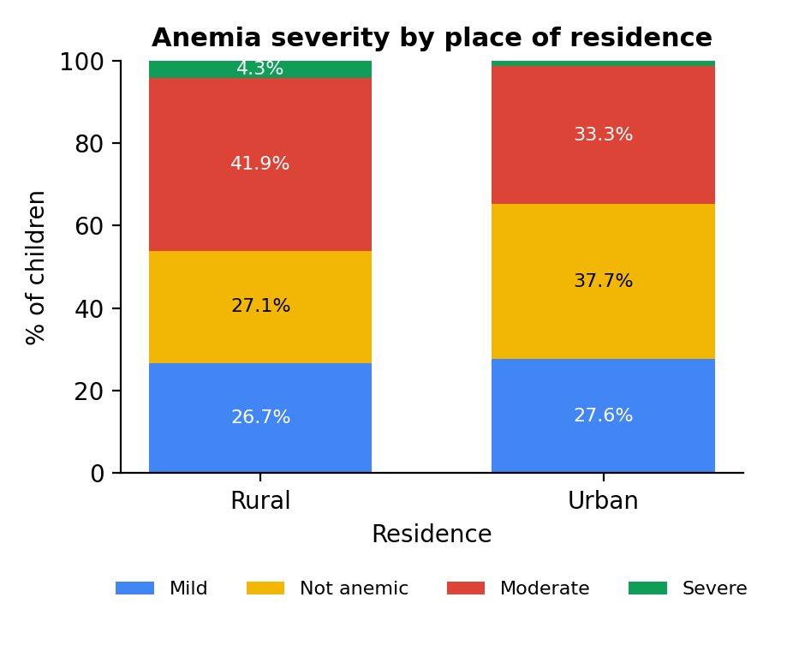
Figure 4. Anemia severity by place of residence (row percentages).

DISCUSSION
Moderate anemia was the most common category overall, and combined with severe anemia it affected 41.7% of children with recorded measurements (3,927 moderate plus 322 severe children, 4,249 in total). Anemia severity looked clearly different across the socioeconomic groups examined.
Which factors showed the strongest differences?
Household wealth and mother’s education showed the largest gaps, each about 30 percentage points between the two ends of the scale (54.0% vs 24.0% for wealth; 50.3% vs 20.2% for education). The two gaps are almost identical in size, so this analysis does not point to one as clearly stronger than the other. Residence showed a smaller, but still visible, gap of 11.5 percentage points (46.2% rural vs 34.7% urban).
Do patterns differ between urban and rural areas?
Children in rural areas had a higher share of moderate/severe anemia (46.2%) than children in urban areas (34.7%). The wealth and education patterns are reported for all children combined; they were not broken down separately for urban and rural areas in this analysis.
What this means in practice. The children with the greatest share of moderate/severe anemia are those in the poorest households and those whose mothers have no education. These groups, along with rural children, may be places where health programs and policymakers want to look more closely. These are descriptive patterns in the data only; they do not tell us why the differences exist and do not establish that wealth, education or residence cause anemia.

CONCLUSION
Among 10,182 children aged 0–59 months with recorded anemia measurements in the 2018 NDHS data, moderate anemia was the largest single severity category (38.6%), followed by not anemic (31.2%), mild (27.0%) and severe (3.2%).
The descriptive results show clear differences in childhood anemia severity across household wealth, mother’s education and residence. Moderate/severe anemia was 24.0% among children in the richest households versus 54.0% in the poorest; 20.2% among children whose mothers had higher education versus 50.3% among those whose mothers had no education; and 34.7% in urban areas versus 46.2% in rural areas.
The key insight: children in poorer households and children of mothers with no education had more than twice the share with moderate/severe anemia of children in the richest households or with higher-educated mothers, with a smaller but visible gap between rural and urban areas. These findings describe patterns in the data and do not establish statistical significance or causation.

RECOMMENDATIONS
The recommendations below follow from the descriptive patterns and are framed as areas for attention and further work, not as proven solutions.
- Prioritize attention on the groups with the highest share of moderate/severe anemia: children in the poorest households, children whose mothers have no education, and rural children.
- Consider wealth and mother’s education together when planning outreach, since both showed gaps of about 30 percentage points.
- Investigate the missing anemia measurements to understand why 70.0% of records lack a child measurement, and improve coverage so future analyses can represent all children.
- Carry out further analysis using statistical testing, survey weights and methods that account for several factors at once, to see how far these patterns hold up.
- Examine wealth and education separately within urban and rural areas to understand whether the patterns differ by setting.

